MOVING RATING PREDICTION
- To predict movie ratings using Machine Learning.
DataSet Description :
- The dataset contains details like year, votes, duration and rating.
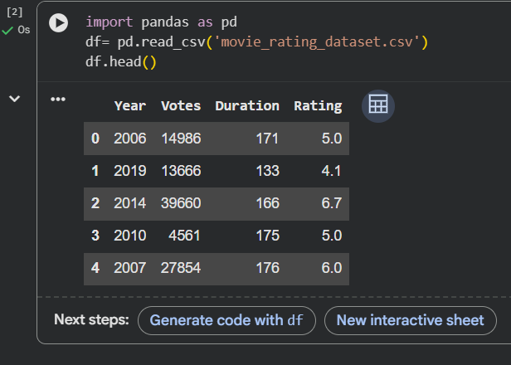
Tools & Technologies Used :
- Python
- Google Colab
- Pandas
- Numpy
- Matplotlib
- Seaborn
- Scikit-learn
Data Preprocessing:
- Missing values were checked & dataset was analysed using pandas functions.
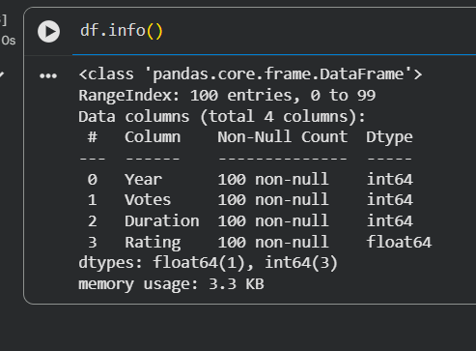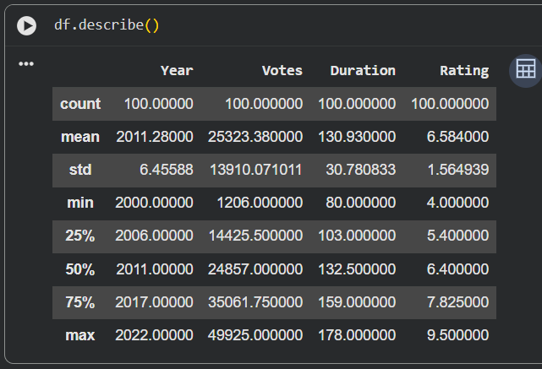
This is code file
Data Visualization : Heatmap used to analyse relationships between variables.
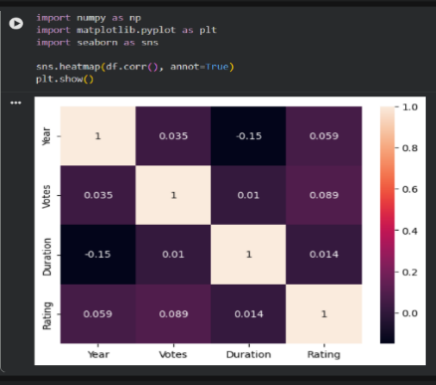
Model Building : Linear Regression algorithm was used for movie rating prediction.
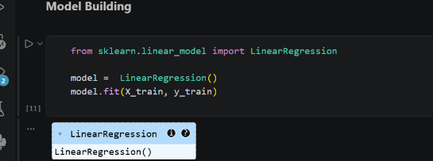
Prediction & Result :
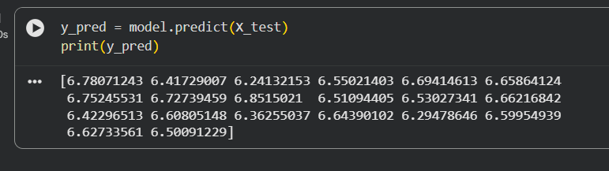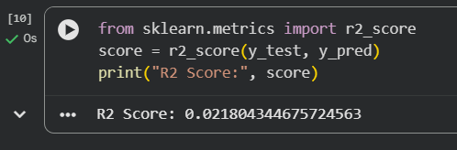
Graph :
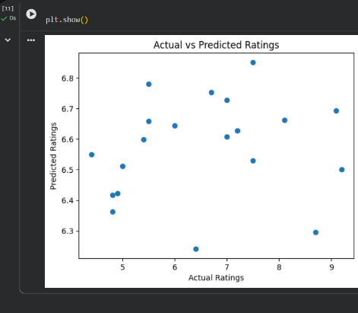

Conclusion :
- This project helped in understanding movie rating prediction using machine learning including preprocessing, training, and prediction steps.

